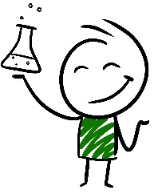
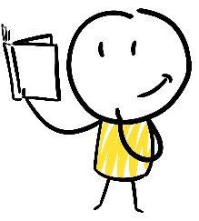
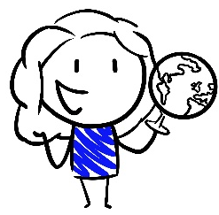
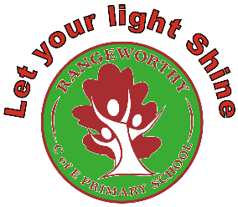
Rangeworthy Mission Overview
Kingfisher Class (Years 3, 4, 5 and 6)
 | Cycle 1 | Cycle 2 | Cycle 3 | Cycle 4
Term 1 | 1.1 Where does our energy come from?  Electricity (Y4): electrical appliances, simple circuits, switches, conductors and insulators  Electricity (Y6): number and voltage of cells, how components function, circuit diagrams  The distribution of natural resources including energy  Land use patterns  Climate change and sustainability (non stat) | 2.1 Where does our water come from?  States of matter (Y4): solids, liquids and gases, heating and cooling, evaporation and condensation  The water cycle  Rivers  The distribution of water | 3.1 What is underneath our feet?  Rocks (Y3): different kinds of rocks, fossil formation, soil  Volcanoes and earthquakes | 4.1 Why are rainforests so important?  Locate the world’s countries, using maps to focus on South America  The Equator and Tropics of Cancer and Capricorn  Comparison study of a region of the United Kingdom and a region within South America  Living things (Y4): environmental change
Term 2 | 1.2 What was important to the ancient Egyptians?  An overview of where and when the first civilizations appeared and a depth study of Ancient Egypt | 2.2 Who settled in Britain and why?  Britain’s settlement by Anglo-Saxons and Scots  The Viking and Anglo-Saxon struggle for the Kingdom of England to the time of Edward the Confessor | 3.2 How did bronze and iron change life in Britain?  Changes in Britain from the Stone Age to the Iron Age  Forces and magnets (Y3): contact forces, magnetic forces, magnetic materials, poles | 4.2 How did flight take off?  Beyond 1066- history of flight  Forces (Y3): how things move  Forces (Y5): gravity, air resistance, water resistance, friction, simple machines
Term 3 | 1.3 What happens to the food we eat?  Animals, including humans (Y3): skeletons, muscles, types and amounts of nutrition  Animals, including humans (Y4): the digestive system, types of teeth, food chains | 2.3 How do living things grow?  Living things (Y5): differences in life cycles of a mammal, amphibian, insect and bird, reproduction in some plants and animals  Animals, including humans (Y5): changes as humans develop to old age | 3.3 How have living things evolved over time?  Evolution and inheritance (Y6): fossil evidence, offspring, variation, adaptations  Latitude and longitude  Climate zones, biomes and vegetation belts | 4.3 How do our choices affect our bodies?  Animals including humans (Y6): circulatory system, impact of diet, exercise and drugs, transportation of nutrients and water
Term 4 | 1.4 What is Europe like?  Locate the world’s countries, using maps to focus on Europe  Comparison study of a region of the United Kingdom and a region in a European country  Mountains | 2.4 How are we connected to the rest of the world?  Economic activity including trade links, and the distribution of natural resources including energy, food, minerals  North America  Migration and refugees (non stat) | 3.4 Would you rather live in a village, town or city?  Name and locate counties and cities of the United Kingdom Types of settlement and land use  Sound (Y4): vibrations, pitch, volume | 4.4 What is out there and how do we know?  Earth and space (Y5): movement of Earth and planets, movement of the Moon, spherical bodies, day and night  Northern and Southern Hemispheres, Prime/Greenwich Meridian and time zones
Term 5 | 1.5 How did World War II impact Britain?  A study of an aspect or theme that extends pupils’ chronological knowledge beyond 1066- a significant turning point in British history  A local history study | 2.5 Why should we remember the Golden Age of Islam?  A non-European society that provides contrasts with British history- early Islamic civilization, including a study of Baghdad c. AD 900 | 3.5 What impact did the Romans have on Britain?  The Roman Empire and its impact on Britain | 4.5 How have the Ancient Greeks influenced the modern world?  Greek life and achievements and their influence on the western world
Term 6 | 1.6 How can we group, mix, separate and change materials?  Properties and changes of materials (Y5): grouping materials, dissolving, separating mixtures, uses of everyday materials, reversible and irreversible changes | 2.6 How do we see?  Light (Y3): light and dark, reflections, dangers of the sun, shadows  Light (Y6): straight lines, how objects are seen, shadows | 3.6 What do plants need to grow healthily?  Plants (Y3): parts of plants, requirements for life and growth, water transportation, life cycles | 4.6 How can we sort living things?  Living things (Y4): grouping in a variety of ways, classification keys  Living things (Y6): classifying according to characteristics

Rationale- why this, why now?
Overall:
- Balance of science, history and geography in each cycle
- Balance of biology/chemistry/physics in each cycle
- Have grouped together certain science units that require knowledge to be taught in certain order
- Have spread out other science units to allow certain topics to come up multiple times
Cycle 1  ~5 science units  2 history units  2 geography units | Cycle 2  ~5 science units  2 history units  2 geography units | Cycle 3  ~5 science units  2 history units  3 geography units | Cycle 4  ~5 science units  2 history units  2 geography units
- Grouped the electricity units together to allow for control in teaching order  - WWII mission follows on well from Europe mission as locational knowledge of key countries will support learning  - Materials unit will need to include some input on solids, liquids and gases from Y4 unit as not all children will have this prior knowledge | - Grouped the light units together to allow for control in teaching order  - Grouped together Y5 living things and Y5 animals, including humans as the units are very well matched and make sense to teach together  - Anglo-saxon/Viking unit follows on well from rivers as rivers often impacted where people settled  - Golden Age of Islam mission links well with ‘How are we connected to the rest of the world?’ mission as it traces the history of trade and transport back through history  - Golden Age of Islam and Anglo-Saxons/Vikings work well in same cycle as they provide a good contrast of a similar time in history in different parts of the world  - Golden Age of Islam links well to Light as we look at the work of Early Islamic scientist, Ibn al-Haytham (the father of modern optics) | - Prehistory and Romans are in the same cycle as the Romans unit picks up exactly at the end of the prehistory unit (end of the Iron Age) so supports children’s chronological learning  - Romans links well to village/town/city mission as many local settlements have Roman roots (can be traced through place names)  - ‘What is underneath our feet?’ and Evolution mission in same cycle as they are linked through fossils  - Prehistory and Evolution missions work well in same cycle as children require knowledge of long timelines! Also able to address misconceptions around dinosaurs living alongside humans  - Sound doesn’t really link to anything so have put it alongside one of the smaller missions  - Magnets also doesn’t really link but need to teach in this cycle to keep the balance of science equal | - Grouped the classification units to allow for control in teaching order  - Have kept forces and space in same cycle as knowledge of gravity is very useful prior knowledge to have before learning about space  - Greeks follows on well from Space as we look at the work of Aristotle and Ptolemy  - Have moved the environmental change objective from Y4 living things as it links perfectly with deforestation

