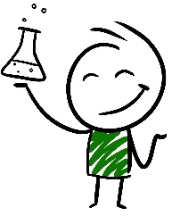
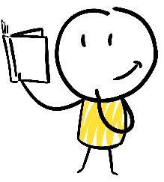
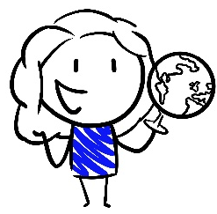
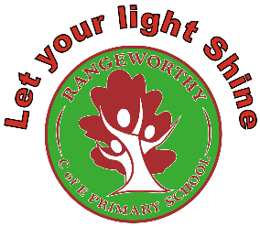
Rangeworthy Mission Overview
Robin Class (EYFS, Year 1 and Year 2)
 | Cycle 1 | Cycle 2 | Cycle 3
Term 1 | 1.1 How does the weather affect us?  Countries and capital cities of the UK and its surrounding seas  Seasonal and daily weather patterns  Key physical features: season and weather  Hot and cold areas, the Equator, North and South Poles  Fieldwork  Seasonal changes Y1: Observe and describe weather, day length variation | 2.1 What is our local area like?  Countries and capital cities of the UK and its surrounding seas  Key physical features: forest, hill, river, soil, vegetation  Key human features: town, village, farm, house, office, shop,  Aerial photos and plan perspectives  Simple maps and symbols  Compass directions and directional language  Fieldwork | 3.1 What is the UK like?  Countries and capital cities of the UK and its surrounding seas  Key physical features: forest, hill, mountain, river, soil, valley, vegetation, beach, cliff, coast, sea, ocean  Key human features: city, town, village, farm, factory, house, office, shop, port, harbour  Aerial photos  Compass directions
Term 1 | 1a What is autumn like? (focus on animal micro-habitats)  Seasonal changes Y1 | 2a What is autumn like? (focus on plants)  Seasonal changes Y1 | 3a What is autumn like? (focus on signs of autumn)  Seasonal changes Y1
Term 2 | 1.2 What do we remember on the 5th November?  events beyond living memory that are significant nationally or globally (The Gunpowder Plot) | - What does a poppy mean?  events beyond living memory that are significant nationally or globally (WWI) | 3.2 What is harvest?  Non-statutory: a nice opportunity to look at life in rural communities in the past, especially how children’s roles have changed.
Term 2 | - How can we stay healthy?  Animals, including humans Y1: basic parts of the human body, senses  Animal, including humans Y2: basic needs of animals, importance of exercise, food, hygiene | 2.3 What happens to our waste?  Materials Y1: distinguish between objects and materials, identify and name everyday materials, simple physical properties, compare and group  Materials Y2: compare the suitability of materials, changing the shape of objects  Sustainability and recycling (non-stat) | 3.3 What lives where?  Living things Y2: living/ dead/ never been alive, how habitats provide basic needs, identify and name habitats, microhabitats, food chains  Animals including humans Y1: carnivores, omnivores and herbivores  Hot and cold areas, the Equator, North and South Poles
Term 3 | 1b What is winter like? (focus on signs of winter)  Seasonal changes Y1 | 2b What is winter like? (focus on animals)  Seasonal changes Y1 | 3b What is winter like? (focus on weather/day length)  Seasonal changes Y1
Term 3 | 1.4 How have toys changed over time?  Changes within living memory (childhood, toys and games) | 2.4 How have houses changed over time?  Changes within living memory (houses and household items) | 3.4 How has transport changed over time?  Changes within living memory (modes of transport: animals, bikes, cars, buses, boats, trains and planes)  Compass directions, directional language and maps
Term 4 | 1.5 What is Australia like?  The world’s seven continents and five oceans  Geography contrast study: non-European country  Key physical features: forest, hill, mountain, river, soil, valley, vegetation, beach, coast, sea, ocean  Key human features: city, town, village, farm, factory, house, office, shop, port, harbour  Use maps, atlases and globes  Aerial photos | 2.5 What are the North and South Poles like?  The world’s seven continents and five oceans  Hot and cold areas, the Equator, North and South Poles  Geography contrast study: non-European country  Use maps, atlases and globes | 3.5 What is it like to live in Shanghai?  The world’s seven continents and five oceans  Geography contrast study: non-European country  Use maps, atlases and globes
Term 4 | 1c What is spring like? (focus on plants)  Seasonal changes Y1 | 2c What is spring like? (focus on signs of spring)  Seasonal changes Y1 | 3c What is spring like? (focus on animals)  Seasonal changes Y1
Term 5 | 1.6 What materials could my den be made from?  Materials Y1: distinguish between objects and materials, identify and name everyday materials, simple physical properties, compare and group  Materials Y2: compare the suitability of materials, changing the shape of objects | 2.6 How do animals grow?  Animals, including humans Y1: identify and name common fish, amphibians, reptiles, birds and mammals, compare the structure of animals  Animals, including humans Y2: animals have offspring which grow into adults | 3.6 What grows near us?  Plants Y1: identify and name common plants, deciduous and evergreen trees, structure of flowering plants and trees  Plants Y2: seeds and bulbs, plants need water, light and a suitable temperature
Term 6 | 1.7 What makes an explorer significant?  the lives of significant individuals in the past (Ibn Battuta, Matthew Henson, Amelia Earhart, Neil Armstrong)  Compass directions, directional language and maps | 2.7 What did Brunel achieve?  significant historical events, people and places in their own locality (Isambard Kingdom Brunel- SS Great Britain, Clifton Suspension Bridge and the Great Western Railway) | 3.7 What is a monarch?  the lives of significant individuals in the past (Queen Elizabeth I, Queen Victoria, Queen Elizabeth II)
Term 6 | 1d What is summer like? (focus on clothing/sun safety)  Seasonal changes Y1 | 2d What is summer like? (focus on weather/day length)  Seasonal changes Y1 | 3d What is summer like? (focus on signs of summer)  Seasonal changes Y1

